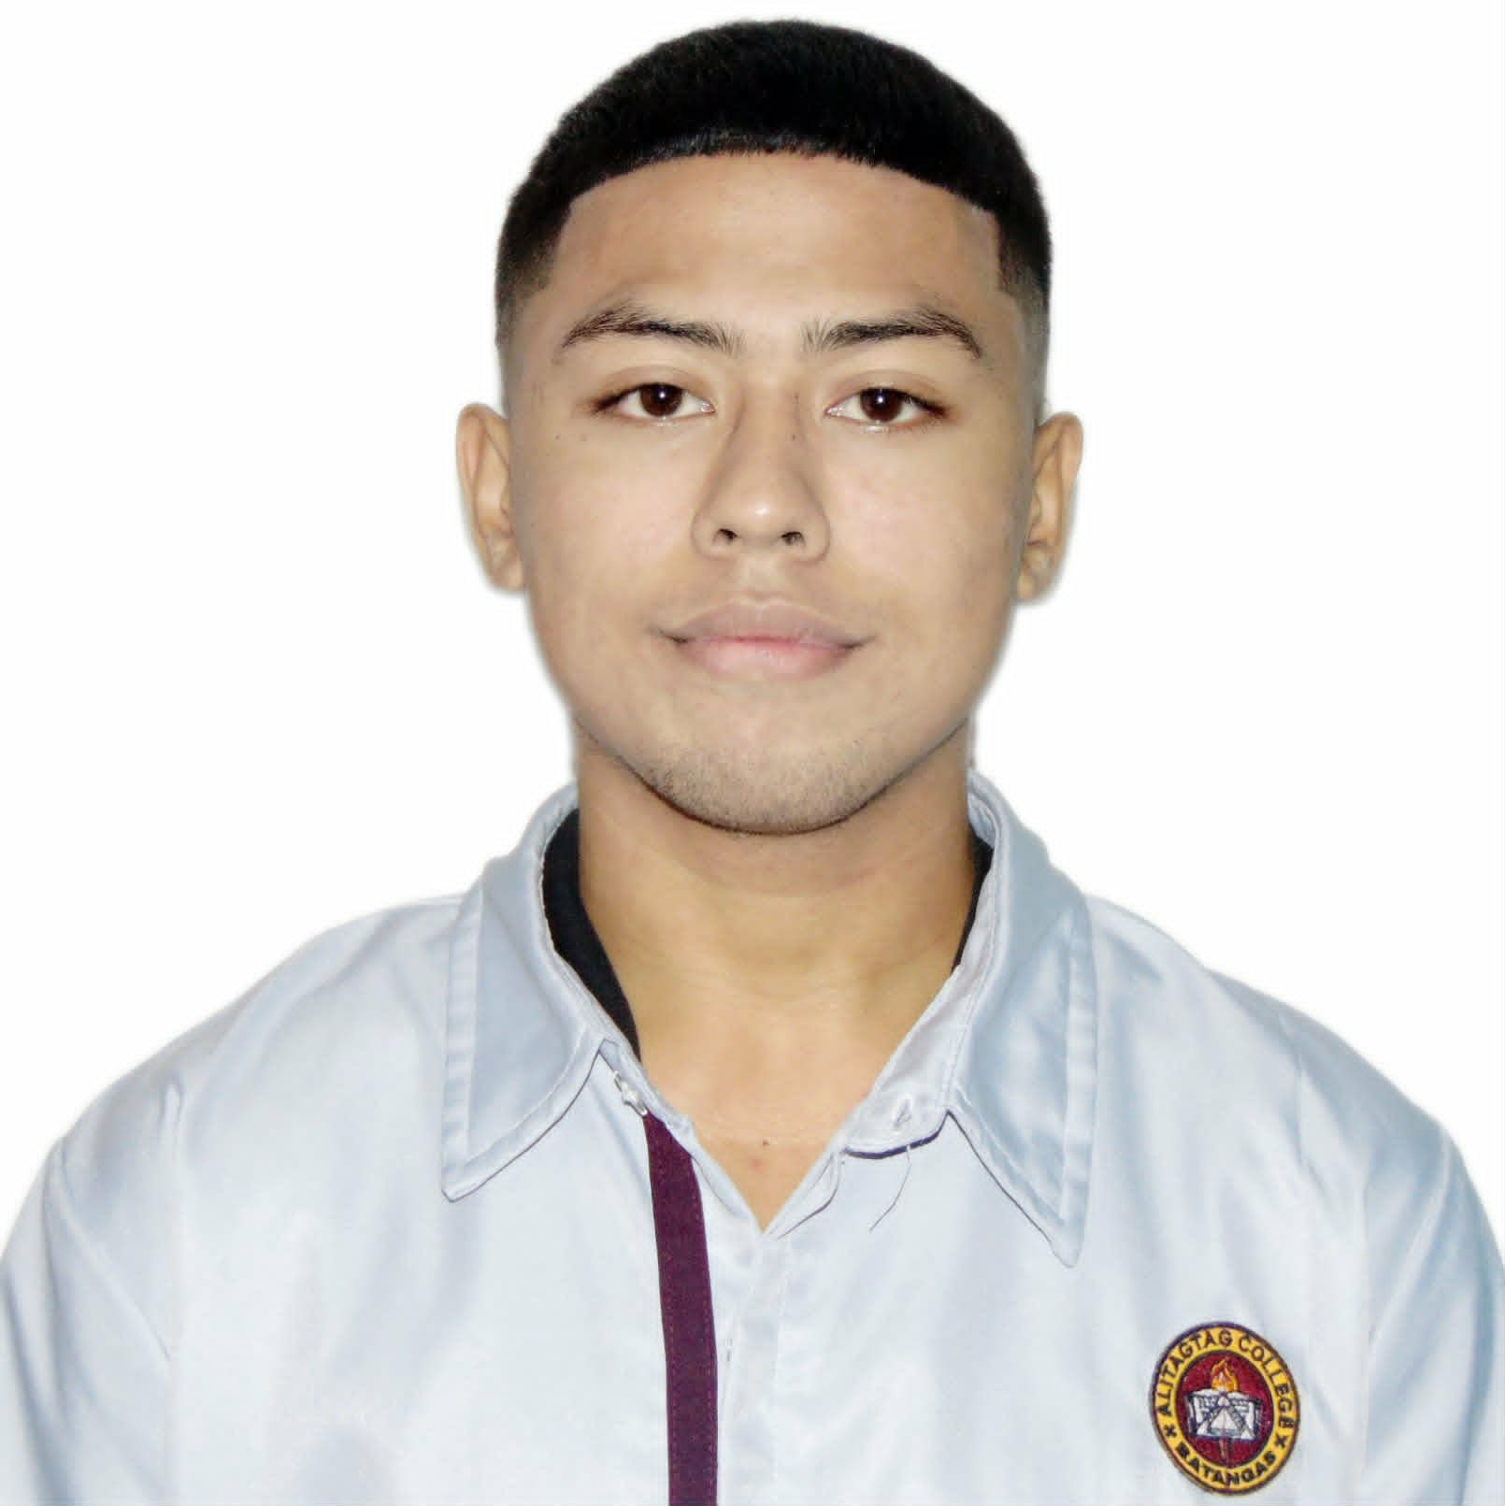
DENZEL LANCE C. CASCAÑO
BACHELOR OF SCIENCE IN COMPUTER SCIENCE
3rd Year College Student
Poblacion West, Alitagtag, Batangas

CAREER OBJECTIVE
A passionate Computer Science student seeking a dynamic role to apply technical knowledge, problem-solving skills, and collaborative abilities while contributing to meaningful and impactful results.
PERSONAL DATA
Age: 20  Gender: Male  Date of Birth: January 13, 2006  Place of Birth: Poblacion West, Alitagtag, Batangas  Civil Status: Single  Nationality: Filipino  Religion: Roman Catholic | Height: 5'7"  Weight: 80 kg  Languages: Filipino, English  Father: N/A  Mother: Riza C.Cascaño  Skills: Leadership, Hardworking, Creativity, Multitasking.
EDUCATIONAL BACKGROUND
Bachelor of Science in Computer Science
Alitagtag College, Inc. • 3rd Year College Student • Present
Senior High School – Humanities and Social Sciences (HUMSS)
Alitagtag College, Inc. High School Department, Main • S.Y. 2023–2024
Secondary
Alitagtag College, Inc. High School Department, Main, Alitagtag, Batangas • S.Y. 2021–2022
Primary
Alitagtag Central School, Alitagtag, Batangas • S.Y. 2017–2018

LEADERSHIP EXPERIENCE
Vice President – Sports Club S.Y. 2026–Present
P.R.O – Sports Club S.Y. 2025–2026
CERTIFICATIONS
Computer Hardware Basics — Cisco Networking Academy
Completion Date: July 19, 2026
Cybersecurity and Cloud Fundamentals 1.0 — Fortinet Training Institute
Date: July 20, 2026
Project Management Essentials Certified — Management and Strategy Institute
Date: July 16, 2026
SKILLS
• Computer Hardware Basics | • Cybersecurity Fundamentals | • Cloud Fundamentals
• Project Management | • Computer Science Fundamentals | • Computer and Technology Skills
• Effective Leadership | • Teamwork | • Communication
 | • Organization and Coordination | • Creativity
OTHER AFFILIATIONS
Member —Computer Club• S.Y. 2021–2023
Member — Sports Club • S.Y. 2021–2023
HONORS AND AWARDS RECEIVED
Secondary
• 2nd With Honors — S.Y. 2021–2022
• 2nd Place Badminton District — S.Y. 2021–2022
• 2nd Place Badminton PRISAB — S.Y. 2021–2022

Tertiary
• 3rd Place Badminton PRISAA – S.Y 2024-2025

CHARACTER REFERENCES
MRS. AIMEE A. HERNANDEZ
IT Instructor, Alitagtag College, Inc. College Department
Engr. TEOFILO GERRY B. BANTA
Principal, Alitagtag College, Inc. Main, Alitagtag, Batangas

I hereby certify that the aforementioned information is accurate and correct with utmost integrity to the best of my knowledge and ability.
___________________________
DENZEL LANCE C. CASCAÑO
Applicant

